Internet and Web Programming

CSE3002

Fall Semester 2020-21

Lab Assignment 5

**ISHAAN OHRI**

**18BCE0265**

**Question:**

Create a program to change the content of the webpage using AJAX.

i. Create a program to change the content of the Jackpot web page using AJAX.

ii. Allow the user to enter any 4 digit number in the textbox.

iii. Whenever the user enters a number ending with 7,show Rs 1000 as prize

money.

iv. When the user enters a number ending with 9,show Rs 3000 as the prize

money.

v. For all other value Rs.100 as the prize money.

vi. Prize Money updation should be done with AJAX.

**Procedure:**

<!DOCTYPE html>: Tells browser that it is an HTML document

<head>: Container for header elements

<title>: Name for toolbar

<body>: Body element for document

<style>: Styles for the different elements

<p>: Defines a paragraph

<input>: Declare input controls that allow users to input data.

type: Defines the type of input text/radio/checkbox

name: Defines the name of the <input> element

id: Unique id to identify

pattern: Defines pattern of input data

required: Compulsory to enter

value: Defines the value of the option in radio/checkbox

XMLHttpRequest: Used to exchange data with a web server

xmlhttp.open is used to get the xml data.

xhttp.send(): Sends the request to the server

**Code:**

**index.html**

<!DOCTYPE html>

<html lang="en">

<head>

<meta charset="UTF-8">

<meta name="viewport" content="width=device-width, initial-scale=1.0">

<title>18BCE0265 ISHAAN OHRI</title>

<link rel="stylesheet" href="./style.css">

</head>

<body>

<h1 align="center">ISHAAN OHRI 18BCE0265</h1>

<h1 align="center">JACKPOT</h1>

<div align="center">

<p>Enter a 4 digit number:</p>

<input id="number" type="number" required>

<br>

<br>

<button id="submit" onclick="loadD()">Submit</button>

</div>

</body>

<script src="./app.js"></script>

</html>

**style.css**

div{

background-color: white;

padding: 50px;

font-size: 40px;

margin: 0;

position: absolute;

top: 50%;

left: 50%;

transform: translate(-50%, -50%);

}

body{

background-color: tomato;

}

button{

background-color: tomato;

padding: 20px;

font-size: 30px;

color: white;

}

input{

font-size: 40px;

text-align: center;

}

**app.js**

function loadD() {

var xhttp = new XMLHttpRequest();

xhttp.onreadystatechange = function () {

if (this.readyState == 4 && this.status == 200) {

cal();

} else {

cal();

}

};

xhttp.open("GET", true);

xhttp.send();

}

function cal() {

var i = document.getElementById("number").value;

if(i.length == 4){

if (i[i.length - 1] == 7) {

alert("You Won Rs 1000");

} else if (i[i.length - 1] == 9) {

alert("You Won Rs 3000");

} else {

lert("You Won Rs 100");

}

} else {

alert("Please enter a 4 digit number");

}

}

**Output:**

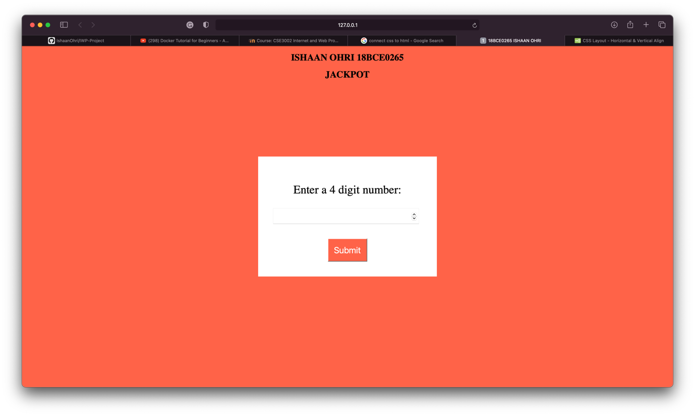

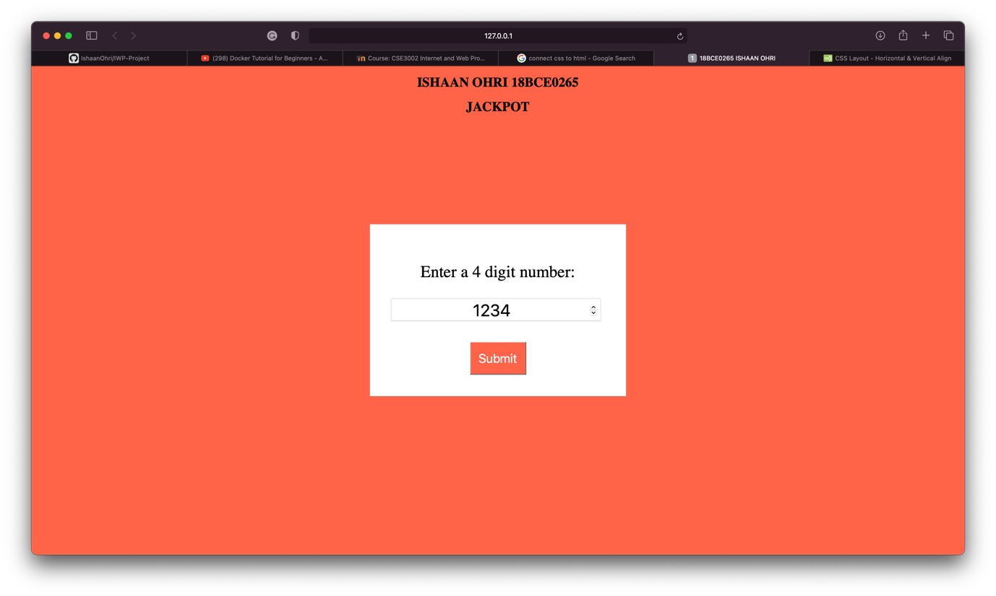

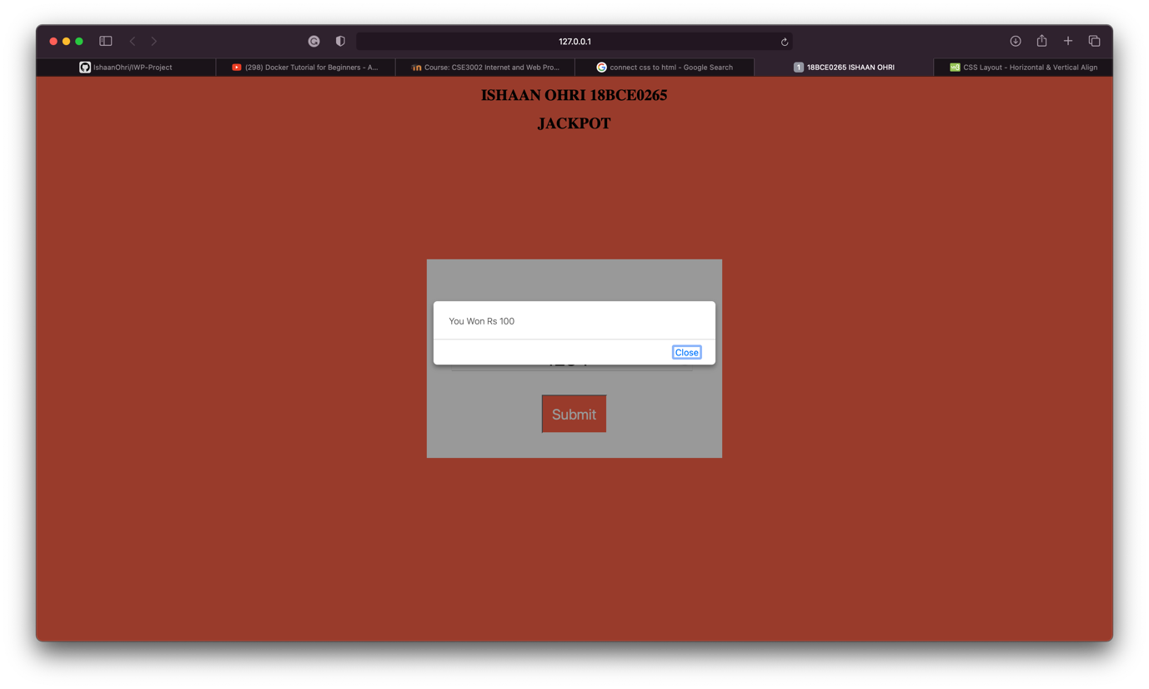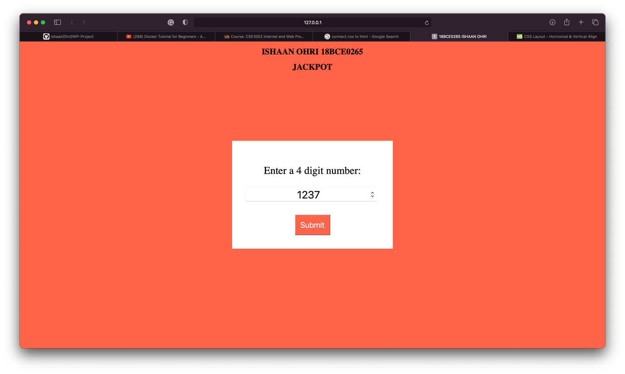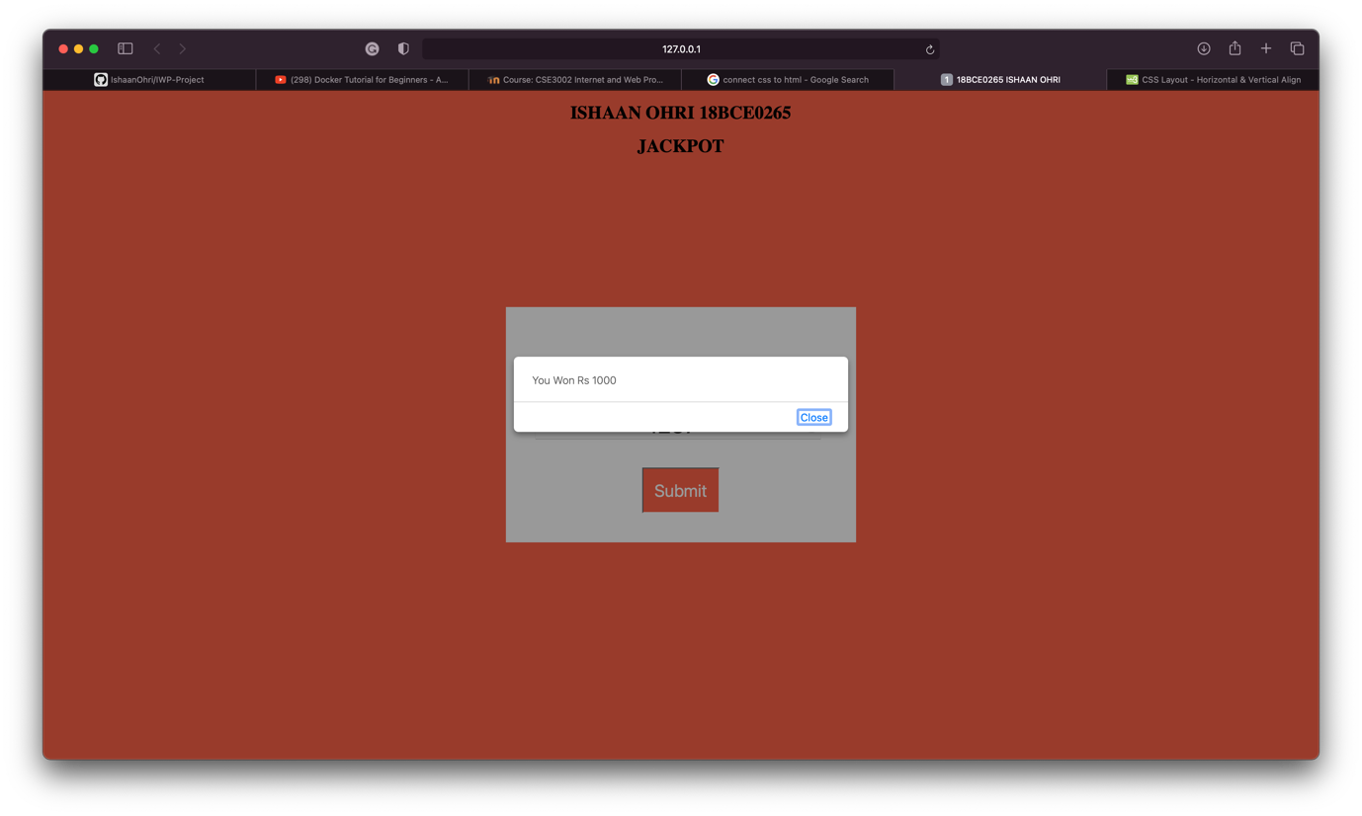

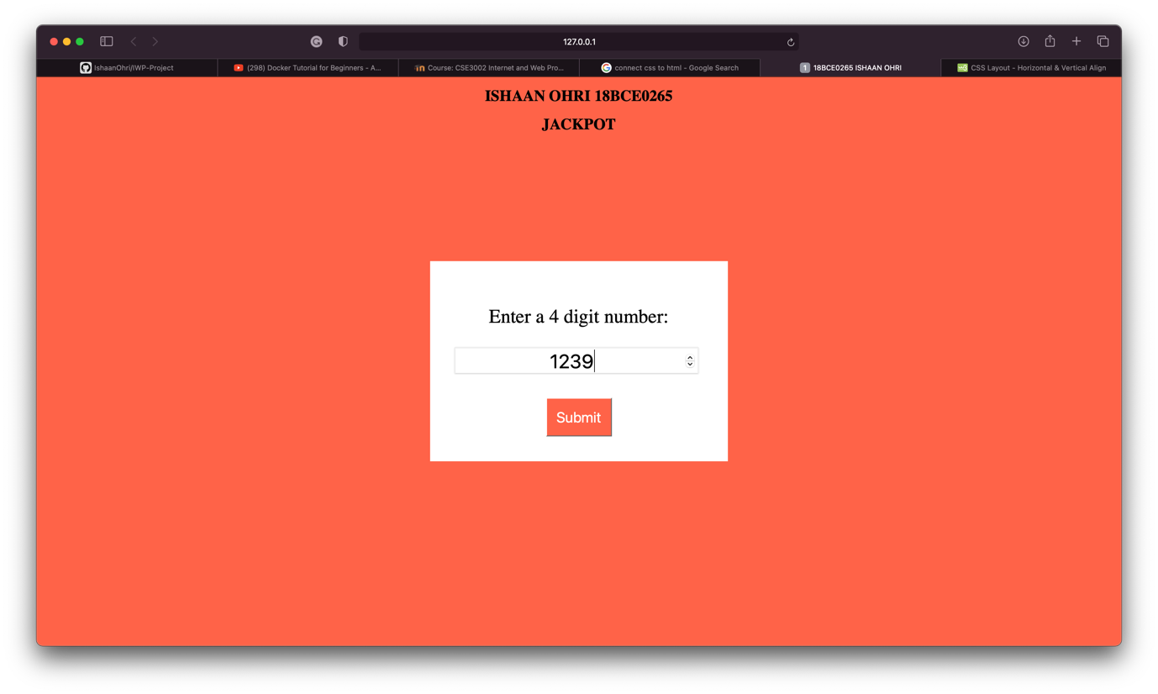

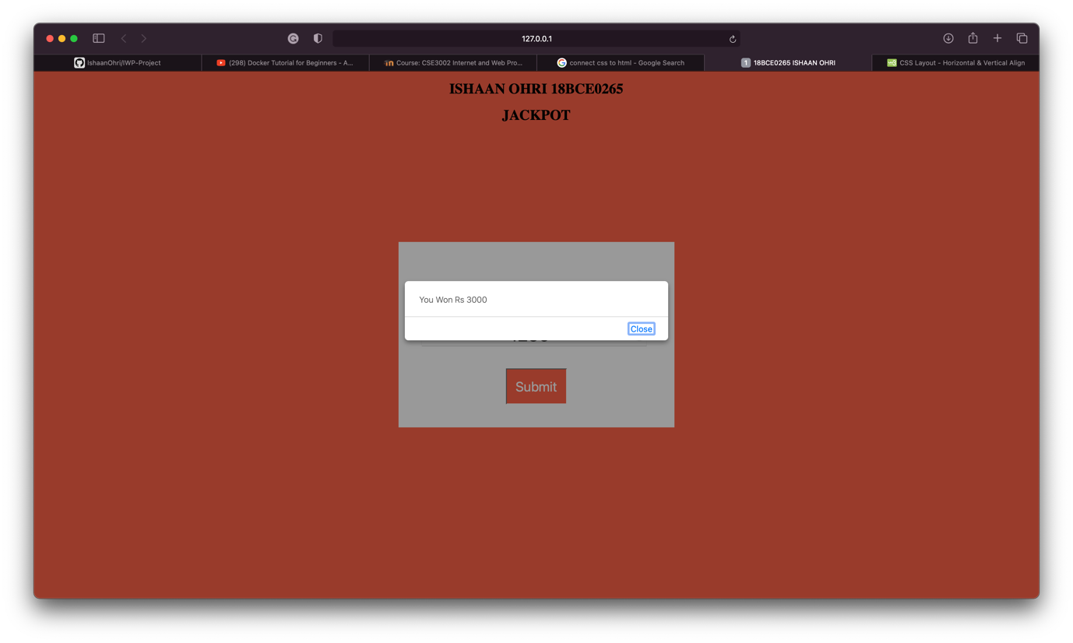

**Question:**

Design a web application using PHP to perform all the Database operations.

Create an address book web application that allows the user to store and retrieve several mailing lists from MySQL database. The address book contains firstname,designation, address1, address2, City, State,emailid. user can add, update and delete all address information’s in the database. Implement search operation with emailid,when emailed is given it return an HTML page with all the complete address information .

**Procedure –**

mysqli_connect(): function opens a new connection to the MySQL server.

$_POST is used to get data submitted from the form post request.

mysqli_query(): function performs a query against a database.

SQL queries are used to insert, fetch and update data in the SQL database.

**Code:**

**index.php**

<?php

include('db_connect.php');

if(isset($_POST['submit'])) {

$name = $_POST['name'];

$designation = $_POST['designation'];

$add1 = $_POST['add1'];

$add2 = $_POST['add2'];

$city = $_POST['city'];

$state = $_POST['state'];

$email = $_POST['email'];

$sql = "INSERT INTO addresses(emailid, name, designation, address1, address2, city, state) VALUES('$email', '$name', '$designation', '$add1', '$add2',

'$city', '$state')";

if(mysqli_query($conn, $sql)) {

echo '<div class="success">

Added Successfully !

</div>';

} else {

echo '<div class="error">

Error : ' . mysqli_error($conn) . '

</div>';

}

}

?>

<?php include 'header.php' ?>

<div class="form-container">

<div class="btns">

<span><a href="index.php"><button>New</button></a></span>

<span><a href="update.php"><button class='disabled'>Update</button></a></span>

<span><a href="delete.php"><button class='disabled'>Delete</button></a></span>

<span><a href="search.php"><button class='disabled' >Search</button></a>

</span>

</div>

<form action="index.php" method='POST'>

<h2>New Entry</h2>

<div class="name">

<input required id="name" type="text" name="name" placeholder="Name">

</div>

<div class="designation">

<input required id="designation" type="text" name="designation" placeh

older="Designation">

</div>

<div class="add1">

<input required id="add1" type="text" name="add1" placeholder="Address1">

</div>

<div class="add2">

<input required id="add2" type="text" name="add2" placeholder="Address2">

</div>

<div class="city">

<input required id="city" type="text" name="city" placeholder="City">

</div>

<div class="state">

<input required id="state" type="text" name="state" placeholder="State">

</div>

<div class="email">

<input required id="email" type="email" name="email" placeholder="Email ID">

</div>

<button name="submit" class="submit" type="submit">Submit</button>

</form>

</div>

</body>

</html>

**update.php**

<?php

include('db_connect.php');

if(isset($_POST['submit'])) {

$name = $_POST['name'];

$designation = $_POST['designation'];

$add1 = $_POST['add1'];

$add2 = $_POST['add2'];

$city = $_POST['city'];

$state = $_POST['state'];

$email = $_POST['email'];

$sql = "UPDATE addresses

SET emailid = '$email', designation= '$designation', address1= '$add1',

address2= '$add2', city= '$city', state= '$state'

WHERE name = '$name'";

if(mysqli_query($conn, $sql)) {

echo '<div class="success">

Updated Successfully !

</div>';

} else {

echo '<div class="error">

Error : ' . mysqli_error($conn) . '

</div>';

}

}

?>

<?php include 'header.php' ?>

<div class="form-container">

<div class="btns">

<span><a href="index.php"><button class="disabled">New</button></a></spa

n>

<span><a href="update.php"><button >Update</button></a></span>

<span><a href="delete.php"><button class="disabled">Delete</button></a>

</span>

<span><a href="search.php"><button class='disabled' >Search</button></a>

</span>

</div>

<form action="update.php" method='POST'>

<h2>Update Entry</h2>

<div class="name">

<input id="name" type="text" name="name" placeholder="Name">

</div>

<div class="designation">

<input id="designation" type="text" name="designation" placeholder="De

signation">

</div>

<div class="add1">

<input id="add1" type="text" name="add1" placeholder="Address 1">

</div>

<div class="add2">

<input id="add2" type="text" name="add2" placeholder="Address 2">

</div>

<div class="city">

<input id="city" type="text" name="city" placeholder="City">

</div>

<div class="state">

<input id="state" type="text" name="state" placeholder="State">

</div>

<div class="email">

<input id="email" type="email" name="email" placeholder="Email ID">

</div>

<button name="submit" class="submit" type="submit">Submit</button>

</form>

</div>

</body>

</html>

**delete.php**

<?php

include('db_connect.php');

if(isset($_POST['submit'])) {

$name = $_POST['name'];

$email = $_POST['email'];

$sql = "DELETE FROM addresses WHERE name= '$name' and emailid= '$email'"

;

if(mysqli_query($conn, $sql)) {

echo '<div class="success">

Deleted Successfully !

</div>';

} else {

echo '<div class="error">

Error : ' . mysqli_error($conn) . '

</div>';

}

}

?>

<?php include 'header.php' ?>

<div class="form-container">

<div class="btns">

<span><a href="index.php"><button class="disabled" >New</button></a></sp

an>

<span><a href="update.php"><button class='disabled'>Update</button></a><

/span>

<span><a href="delete.php"><button >Delete</button></a></span>

<span><a href="search.php"><button class='disabled' >Search</button></a>

</span>

</div>

<form action="delete.php" method='POST'>

<h2>Delete Entry</h2>

<div class="name">

<input id="name" type="text" name="name" placeholder="Name">

</div>

<div class="email">

<input id="email" type="email" name="email" placeholder="Email ID">

</div>

<button name="submit" class="submit" type="submit">Submit</button>

</form>

</div>

</body>

</html>

**db_connect.php**

<?php

// Connect to DB

$conn = mysqli_connect('localhost', 'shivam', '@1SHIVAManand', 'addresses');

if(!$conn){

echo "Connection Error : " . mysqli_connect_error();

}

?>

**search.php**

<?php

include('db_connect.php');

?>

<?php include 'header.php' ?>

<div class="form-container">

<div class="btns">

<span><a href="index.php"><button class="disabled">New</button></a></spa

n>

<span><a href="update.php"><button class="disabled" >Update</button></a>

</span>

<span><a href="delete.php"><button class="disabled">Delete</button></a>

</span>

<span><a href="search.php"><button >Search</button></a></span>

</div>

<form action="search.php" method='POST'>

<h2>Search Entry</h2>

<div class="email">

<input id="email" type="email" name="email" placeholder="Email ID">

</div>

<button name="submit" class="submit" type="submit">Submit</button>

</form>

</div>

<?php

if(isset($_POST['submit'])) {

$email = $_POST['email'];

$sql = "SELECT * from addresses WHERE emailid= '$email'";

$result = mysqli_query($conn, $sql);

if($result) {

$address = mysqli_fetch_assoc($result);

echo "<table>

<tr>

<th>Name</th>

<th>Email ID</th>

<th>Designation</th>

<th>Address 1</th>

<th>Address 2</th>

<th>City</th>

<th>State</th>

</tr>

<tr>

<td>" . $address['name'] . "</td>

<td>" . $address['emailid'] . "</td>

<td>" . $address['designation']. " </td>

<td>" . $address['address1']. "</td>

<td>" . $address['address2']. "</td>

<td>" . $address['city']. "</td>

<td>" . $address['state']. "</td>

</tr>

</table>";

} else {

echo '<div class="error">

Error : ' . mysqli_error($conn) . '

</div>';

}

}

?>

</body>

</html>

**header.php**

<!DOCTYPE html>

<html lang="en">

<head>

<meta charset="UTF-8">

<meta name="viewport" content="width=device-width, initial-scale=1.0">

<style>

@import url('https://fonts.googleapis.com/css2?family=Roboto:ital,wght@0,100;0,300;0,400;0,500;0,700;1,900&display=swap');

* {

font-family: 'Roboto', sans-serif;

box-sizing: border-box;

border-radius:8px;

}

body {

margin: 0;

padding: 0;

background-color:#33FFEB;

}

.header {

font-size: 2rem;

color: red;

padding: 10px 20px;

text-align: center;

}

.form-container {

display: inline-block;

position: relative;

left: 50%;

transform: translate(-50%);

background-color: white;

margin-top: 20px;

padding: 30px 50px;

}

button {

border: none;

font-size: 1.2rem;

background-color: blue;

color: white;

padding: 10px 40px;

cursor: pointer;

}

.disabled {

background-color: #76686c;

}

a {

color: white;

text-decoration: none;

}

.submit {

margin-top: 30px;

width: 100%;

}

h2 {

color: red;

text-align: center;

font-weight: 200;

}

input {

background-color: transparent;

border: 1px solid black;

padding: 10px;

margin: 5px 0;

width: 100%;

font-size: 1.5rem;

color: black;

}

.error {

padding: 5px;

text-align: center;

background-color: red;

color: white;

}

.success {

padding: 7px;

text-align: center;

background-color: orange;

color: white;

}

/* Table */

table {

border: 1px solid #0000FF;

border-collapse: collapse;

margin-top: 20px;

padding: 0;

width: 100%;

table-layout: fixed;

}

table caption {

font-size: 1.5em;

margin: .7em 0 .95em;

}

table tr {

background-color: #0080ff;

border: 2px solid #ddd;

padding: .25em;

}

table th,

table td {

padding: .655em;

text-align: center;

}

table th {

font-size: .95em;

letter-spacing: .15em;

text-transform: uppercase;

}

</style>

<title>SQL Assessment</title>

</head>

<body>

<div class='header'>

ISHAAN OHRI 18BCE0265

</div>

**Output:**

Initially all the fields are empty:

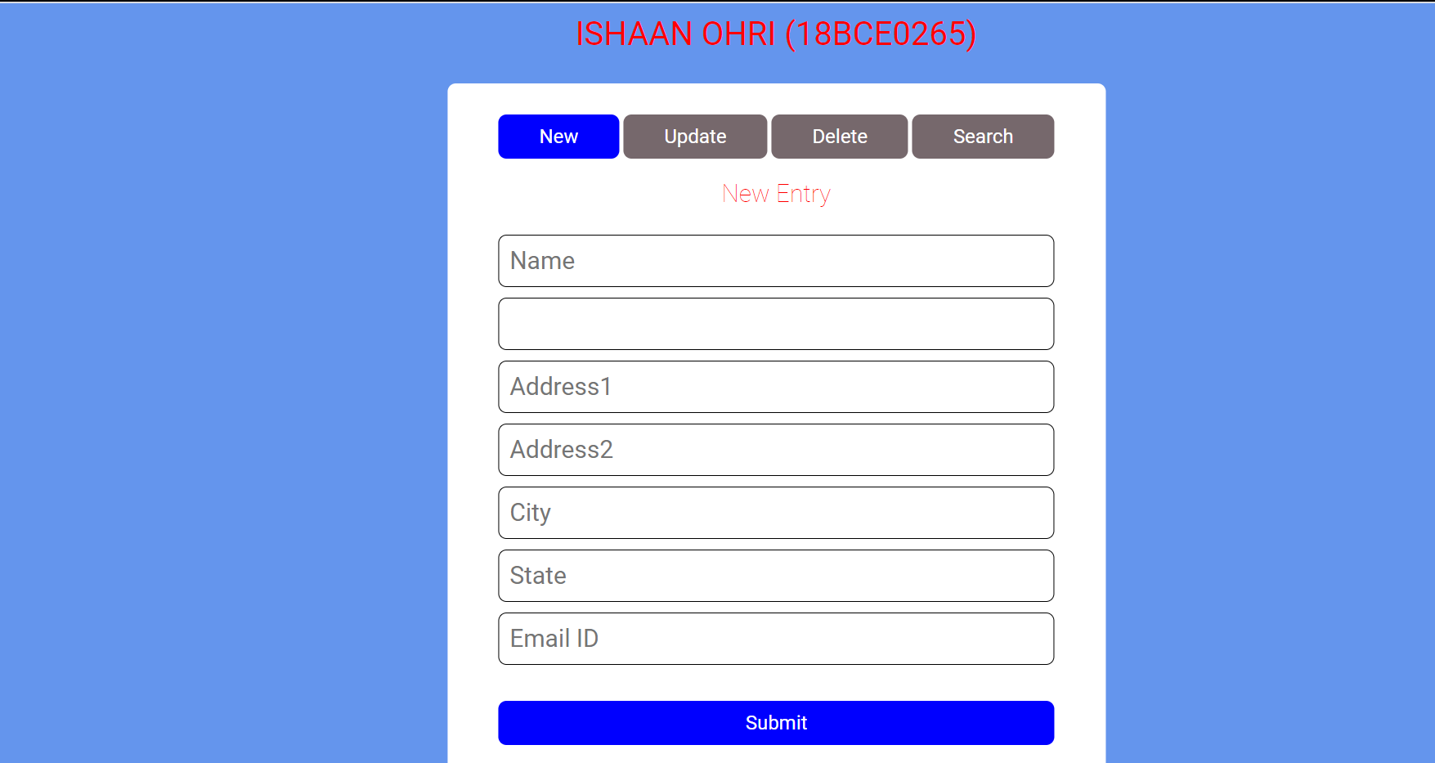

Initially the database is empty:

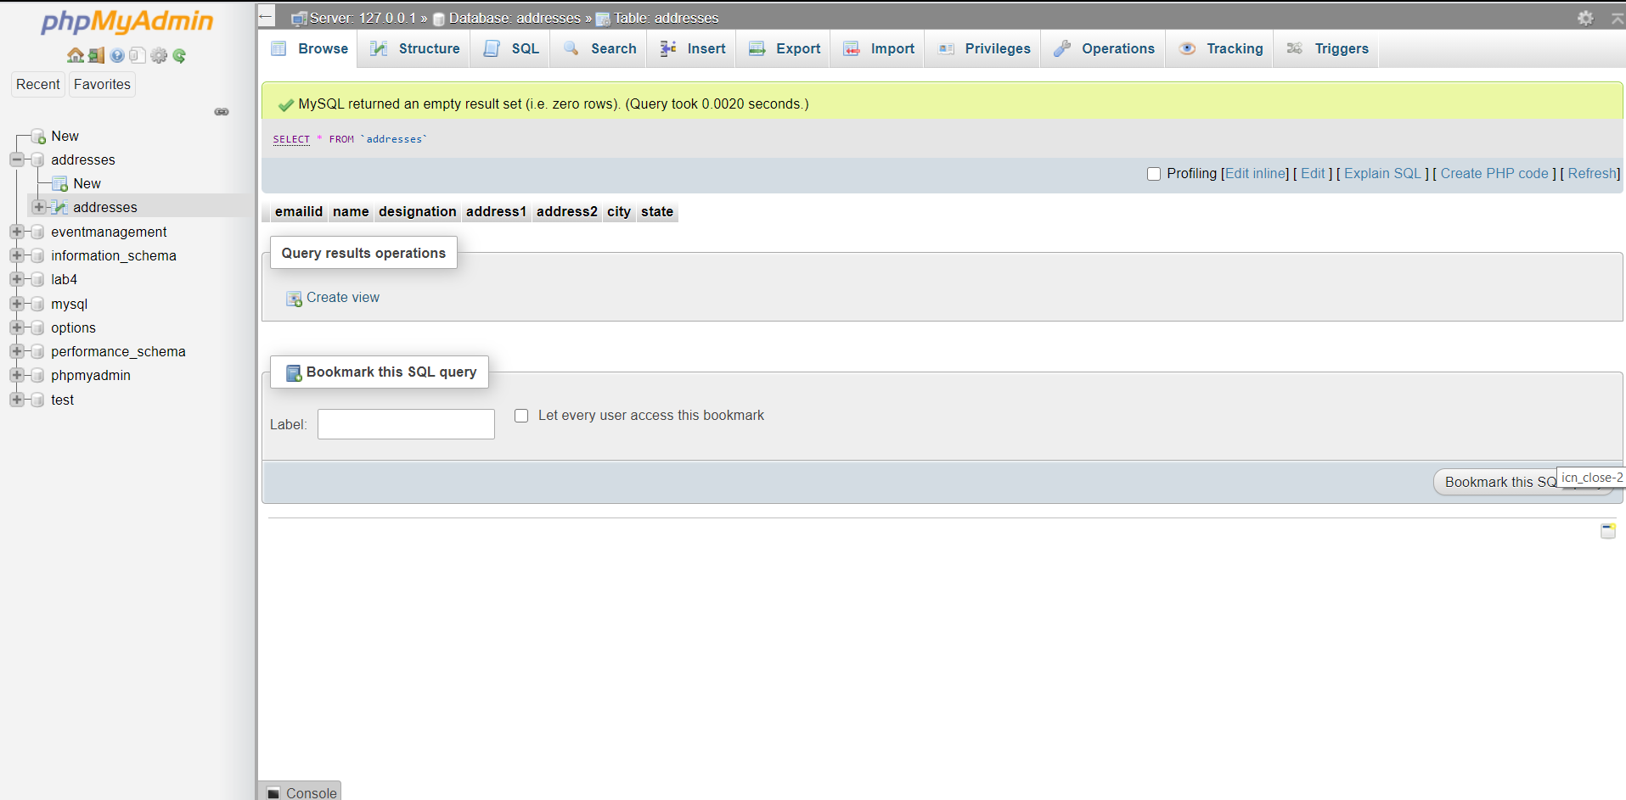

Data is filled in all fields for new entry:

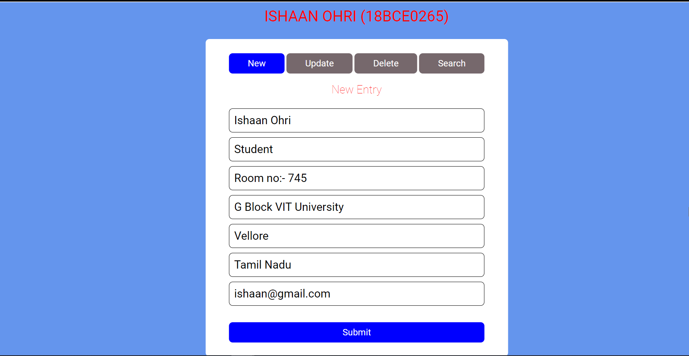

Submit button clicked and data is successfully added to database:

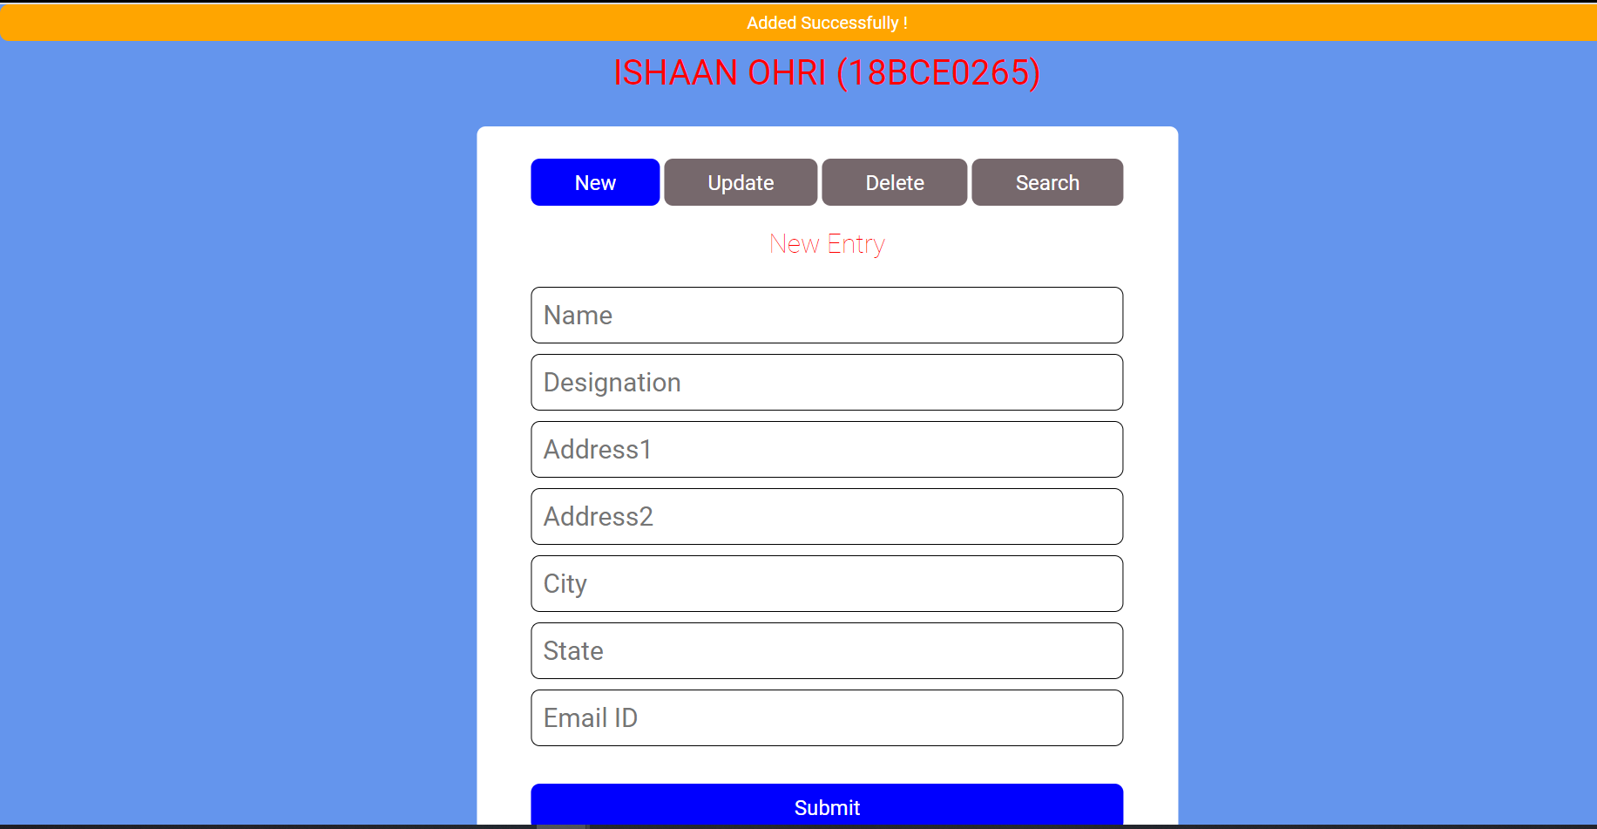

Data entry to database verified from database:

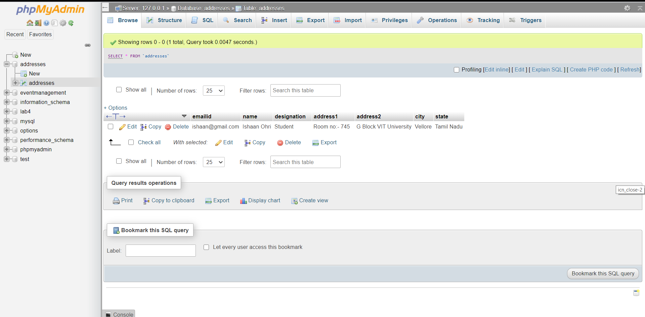

Data is filled in all fields for updating old entry:

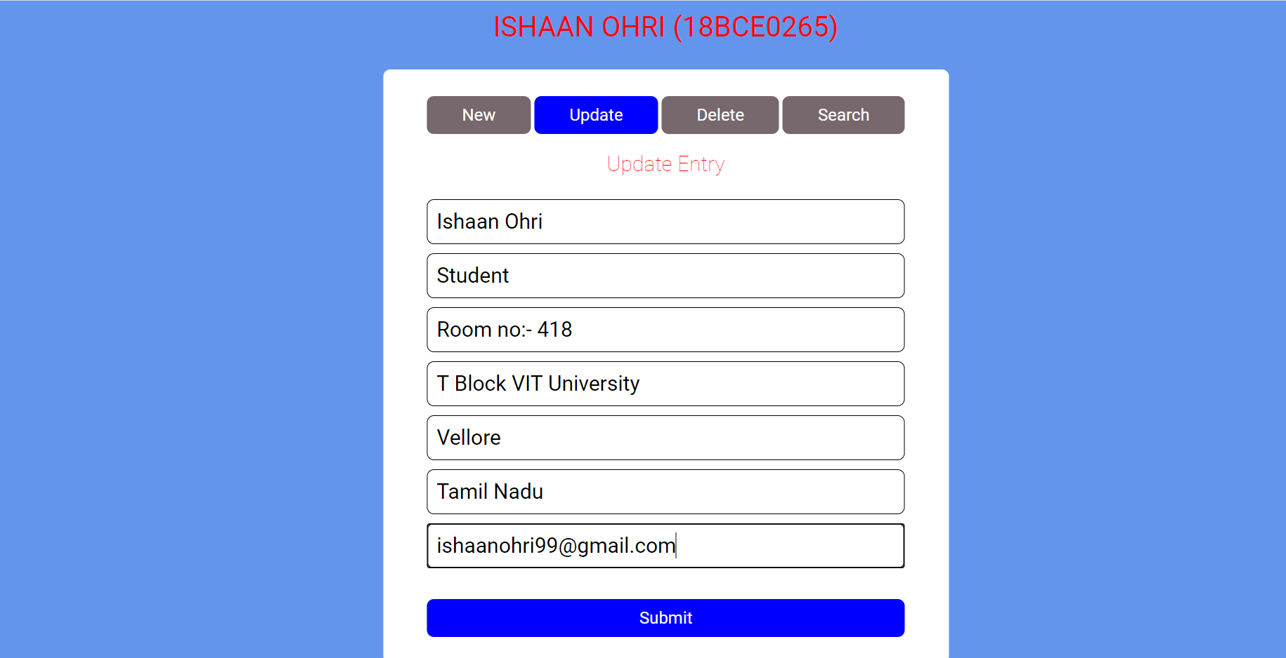

Submit button clicked and data is successfully updated in database:

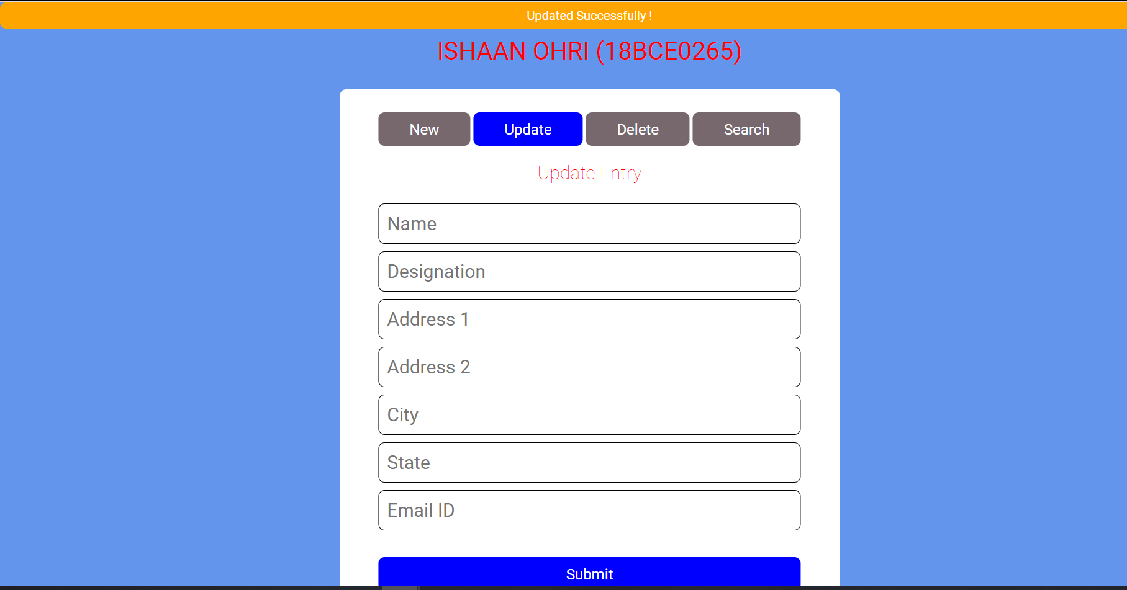

Data update in database verified from database:

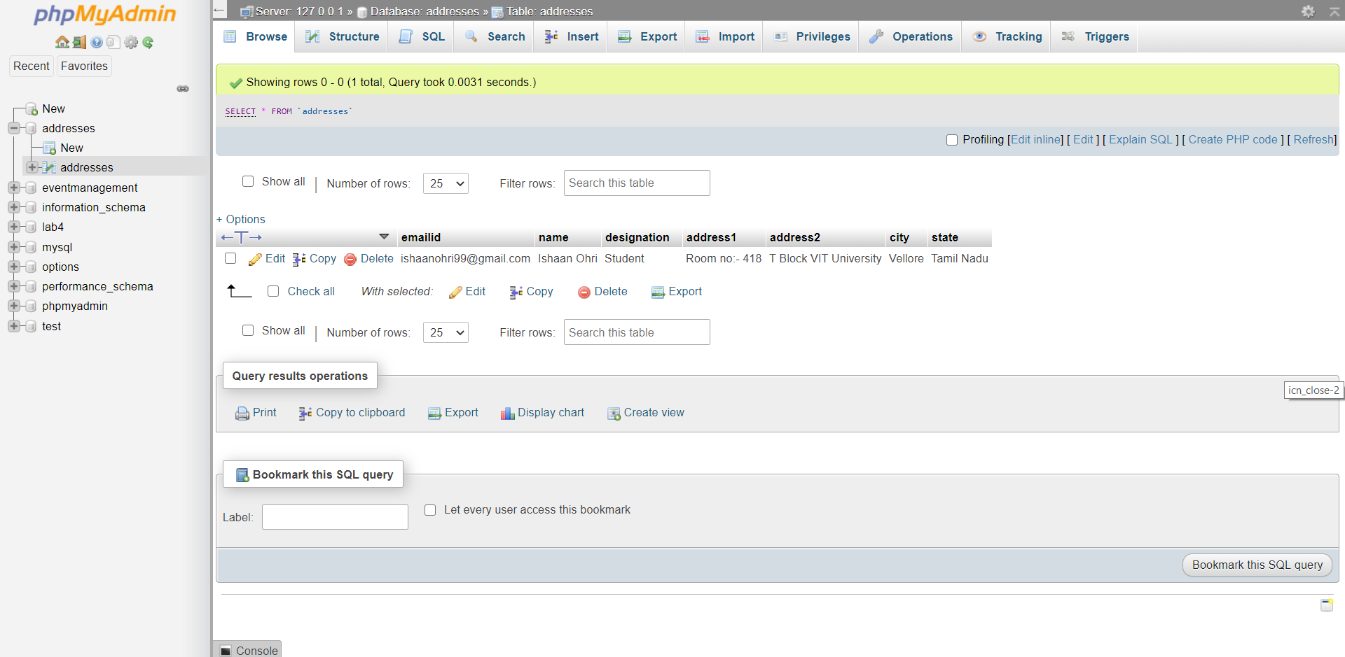

Data is filled in the search field:

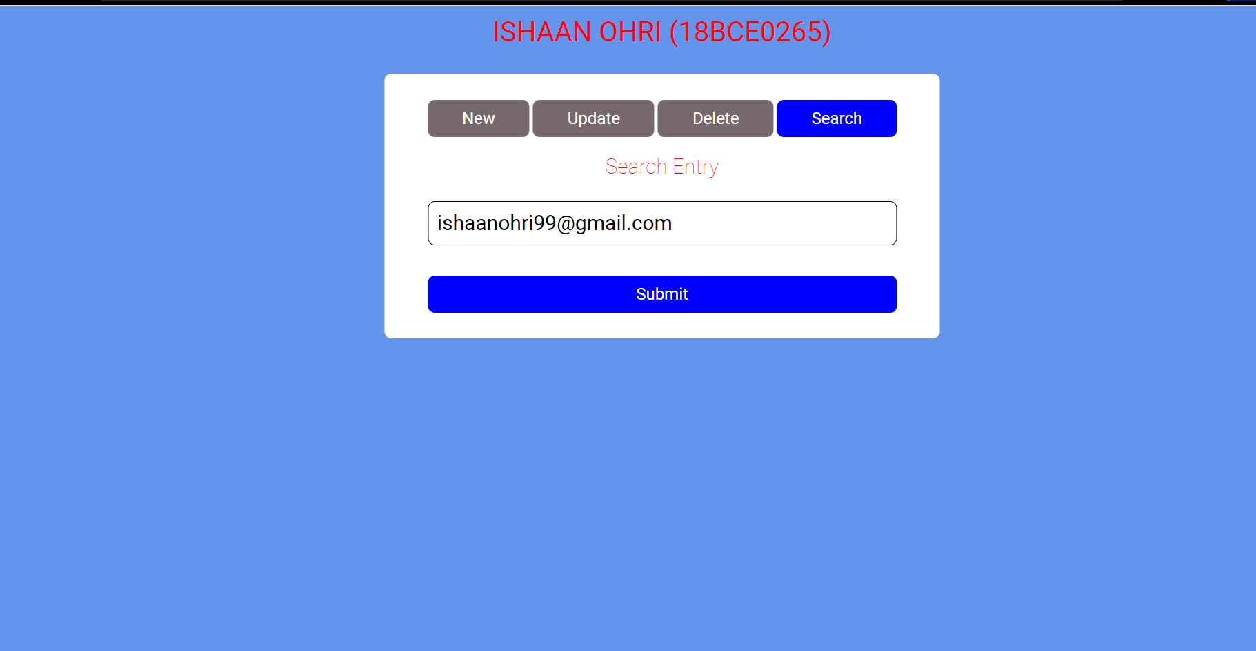

Submit button clicked and data is fetched database:

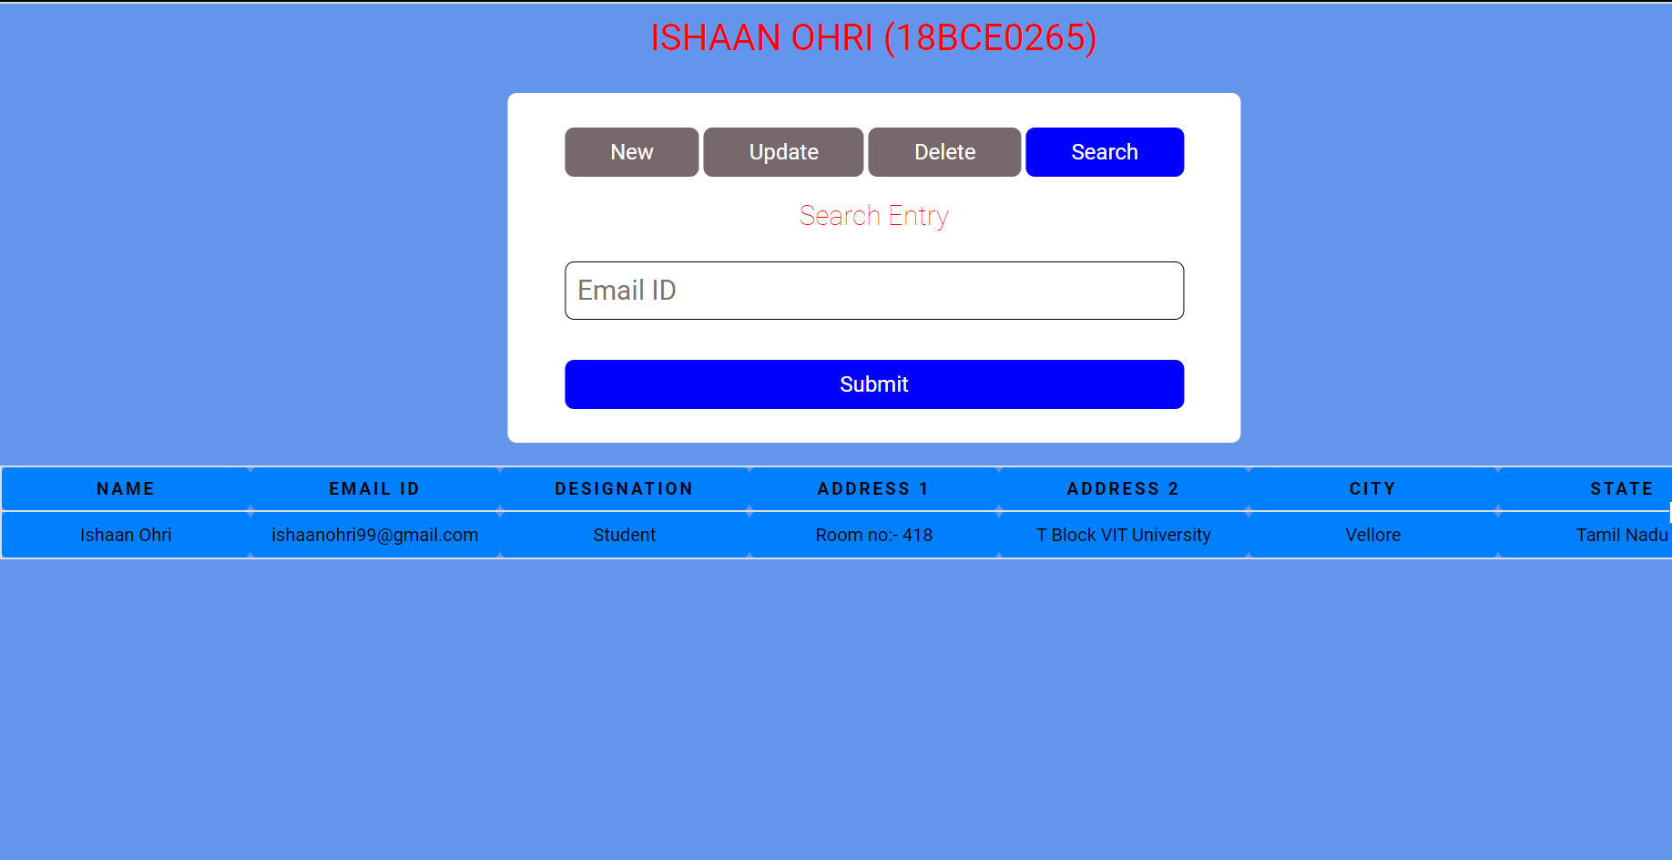

Data is filled in the field to delete the entry:

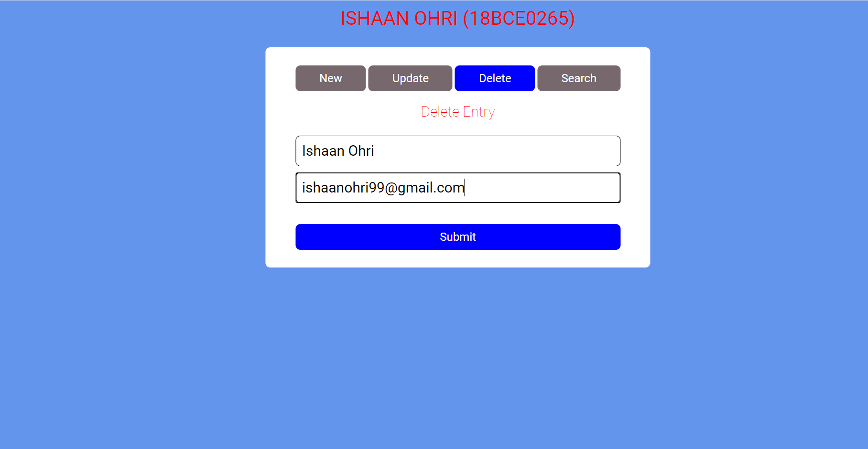

Submit button is clicked and data entry is deleted form database:

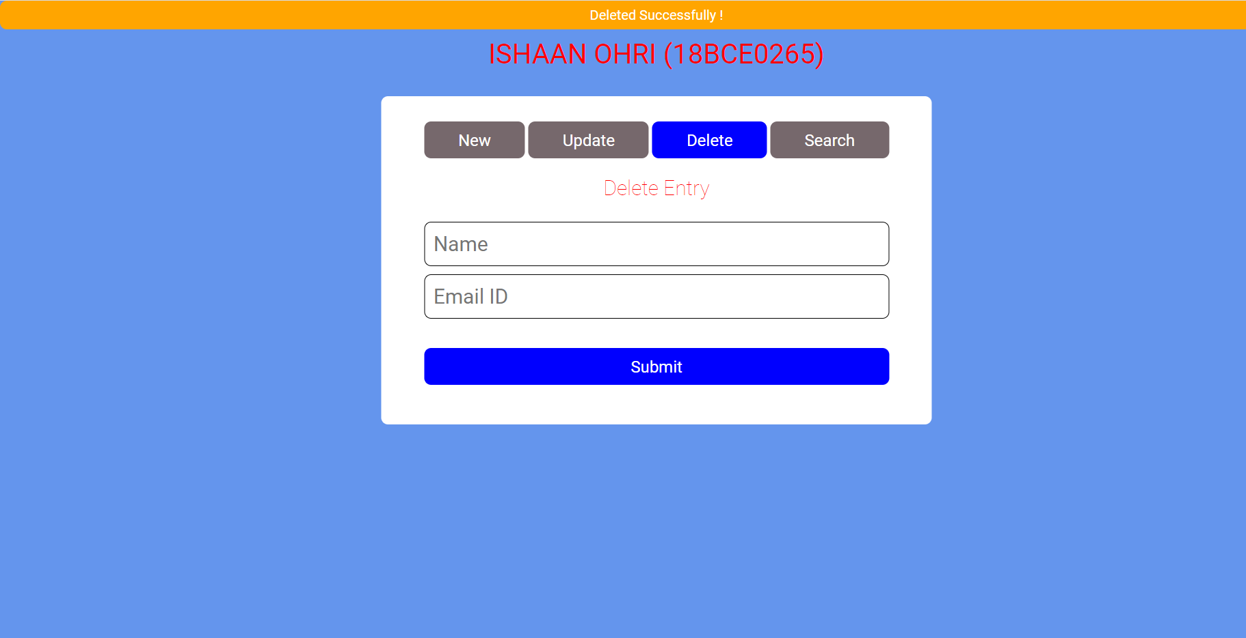

Data deletion from database is verified from database:

